Policy Name | Risk Management Policy
Version No. | V1
Approved by Board on | 12 December 2017
Review Dates | December 2019, December 2021, December 2023
Amendment Dates | Every 36 months

Risk Management Policy

Policy Declaration

SOUTHERN TABLELANDS ARTS INC (“the Organisation”) implements Risk Management across all Organisation activities. The Organisation identifies and treats risks continuously using a step-by-step process involving the identification, analysis, evaluation, treatment, monitoring and review of risks as defined under this Risk Management Policy (“the Policy”).

This Policy confirms Southern Tablelands Arts Inc ongoing commitment to embedding a Risk Management philosophy as part of its everyday working environment and a commitment and mandate to facilitate a strategic and operational risk assessment on behalf of the Organisation. The outcomes of the risk diagnosis and treatment solutions will be the basis of operational plans developed in the form of policies and procedures. Organisation and project management plans, appropriate risk action and control plans and Safe Work Method Statements.

In partnership with the key stakeholders, the Southern Tablelands Arts Inc risk assessment is framed by inclusive consultation and ongoing communication. Risk in the Organisation’s context involves both strategic risk, associated with the Organisation’s function and objectives, and operational risk, arising from day-to-day activities.

Risk is inherent in all operational, administrative and business activities of the Organisation and every member of the Organisation is responsible for the adoption of sound Risk Management practices within their particular area of responsibility.

The Organisation recognises that the aim of Risk Management is not to eliminate Risk completely, but rather to provide the structural framework to effectively manage the Risks across all Organisation activities.

The degree of Risk the Organisation faces at any one time is the combination of the likelihood of an event occurring and the severity of the consequences should it occur. The Organisation’s Risk Management procedures aim to reduce the risk to a minimum level acceptable through treatment strategies to reduce likelihood, consequence or transfer the risk to third parties.

The Organisation acknowledges that Risk Management is an essential element for good corporate governance and good management practice. A strategic and formal approach to Risk Management will improve decision-making, encourage positive outcomes and enhance accountability.

An effective Risk Management procedure also provides the opportunity for management to develop or enhance an Organisation’s culture based on ethical values consistent with those expected of all public and private sector companies and employees.

Risk Management is not a constraining concept. Risk Management is as much about identifying opportunities as avoiding or mitigating losses. It allows the Organisation to seek and take advantage of opportunities to achieve improved outcomes and outputs by ensuring that any risk taken is based on informed decision-making, realistic and measurable objectives and sound analysis of possible outcomes.

The risk diagnosis and treatment strategy is central to ensuring a quality outcome for the Organisation and associated stakeholders through clearly defining the central outcomes and identifying the necessary strategic and operational plans required to achieve these outcomes.

The Risk Management Process is included within all business activities of the Organisation to ensure that the Organisation’s corporate goals and objectives are delivered properly. To achieve this, Risk Management must be an integral function for all within the Organisation.

Managing Risk provides opportunities for managers and staff at every level to continuously improve performance in meeting the challenges of effective Organisation management.

Principles

Southern Tablelands Arts Inc as an Organisation adopts the principles outlined in the international standard ISO31000:2009 in all business activities:

- Risk management creates and protects value.
Risk management contributes to the demonstrable achievement of objectives and improvement of performance in, for example, human health and safety, security, legal and regulatory compliance, public acceptance, environmental protection, product quality, project management, efficiency in operations, governance and reputation.

- Risk management is an integral part of all Organisation processes.
Risk management is not a stand-alone activity that is separate from the main activities and processes of the Organisation. Risk management is part of the responsibilities of management and an integral part of all Organisation processes, including strategic planning and all project and change management processes.

- Risk management is part of decision making.
Risk management helps decision makers make informed choices, prioritize actions and distinguish among alternative courses of action.

- Risk management explicitly addresses uncertainty.
Risk management explicitly takes account of uncertainty, the nature of that uncertainty, and how it can be addressed.

- Risk management is systematic, structured and timely.
A systematic, timely and structured approach to risk management contributes to efficiency and to consistent, comparable and reliable results.

- Risk management is based on the best available information.
The inputs to the process of managing risk are based on information sources such as historical data, experience, stakeholder feedback, observation, forecasts and expert judgment. However, decision makers should inform themselves of, and should take into account, any limitations of the data or modelling used or the possibility of divergence among experts.

- Risk management is tailored.
Risk management is aligned with the Organisation's external and internal context and risk profile.

- Risk management takes human and cultural factors into account.
Risk management recognizes the capabilities, perceptions and intentions of external and internal people that can facilitate or hinder achievement of the Organisation's objectives.

- Risk management is transparent and inclusive.
Appropriate and timely involvement of stakeholders and, in particular, decision makers at all levels of the Organisation, ensures that risk management remains relevant and up-to-date. Involvement also allows stakeholders to be properly represented and to have their views taken into account in determining risk criteria.

- Risk management is dynamic, iterative and responsive to change.
Risk management continually senses and responds to change. As external and internal events occur, context and knowledge change, monitoring and review of risks take place, new risks emerge, some change, and others disappear.

- Risk management facilitates continual improvement of the Organisation.
Companies should develop and implement strategies to improve their risk management maturity alongside all other aspects of their Organisation.

- Compliance
Our decisions and action must always be in line with moral principles and our values. This is what integrity means to us. We measure ourselves by this standard, and we hope that our stakeholders will measure us by the same standard. Compliance with all external and internal rules is essential to integrity and fundamental to our business. Our compliance program instils this awareness in the Executive Director and employees.

Policy Description

Objective

The purpose of this Policy is not to eliminate Risk, but rather to provide the structural framework to effectively manage the Risks involved in all Organisation activities to maximise opportunities, minimise adversity and to achieve improved Organisation outcomes and outputs based on informed decision making.

This Policy has been created to achieve the following:

- establish a framework within which the Organisation will comply with the International Standard in Risk Management ISO31000:2009 (“the Standard”);
- provide a consistent approach to Risk Management in which Risks related to the objects and functions of the Organisation will be identified, evaluated, managed, reviewed and addressed in approval, review and control processes;
- compliance with relevant legislation;
- confirm the Organisation’s commitment to Risk Management and establish the responsibility for and authority of staff to perform and verify work affecting Risk Management;
- foster an environment where staff assume responsibility for managing risks;
- implement Risk Management across the Organisation in accordance with the Standard;
- integrate Risk Management into the management culture of the Organisation;
- provide a structured basis for strategic planning;
- encourage proactive rather than reactive management;
- assist in safeguarding the Organisation’s assets, staff, finances, property and reputation;
- improve the quality of decision making throughout the Organisation;
- reduce costs through better targeted and more effective controls.

Content and Implementation

SOUTHERN TABLELANDS ARTS INC adopts the Risk Management approach and general methodology specified in the International Standard. All Organisation business processes, commercial activities and functions must adopt a Risk Management approach consistent with the Standard. The Organisation’s Risk Management approach and methodology, is set out in this Policy at Annexure A.

Scope
The Policy shall be applied to decision making through all levels of the Organisation and in relation to any function or activity likely to have any significant impact on the Organisation’s operations, irrespective of the level of financial exposure.

The Policy is applicable to all areas of the Organisation including but not limited to:

  - Overall corporate management
  - Governance
  - Financial management and sustainability
  - Stakeholder management
  - Work, Health, Safety & Environment
  - Reputational risk and exposure
  - The Regional Arts Network
  - Administration
  - Human Resources
  - Operational Financial management including budgeting and control
  - Contracting;
  - Operations

This risk assessment only examines the day-to-day operations of the business in delivering its strategic objectives. This risk assessment does not cover the delivery of projects and programs such as regional conferences, concerts, festivals or other events.

All directors, staff members, volunteers and contractors of the Organisation must comply with this Policy.

The Organisation shall apply the Policy:

- In the general operations of the Organisation and delivery of projects and when decisions are to be made including, but not limited to, the following:

  - contracting (whether for goods, services) with a consideration in excess of $1,500;
  - undertaking Organisation business in public places;
  - commercialisation of intellectual property; and
  - when developing new strategies and procedures;
  - when reviewing existing strategies and procedures;
  - when managing products;
  - when introducing significant change; and
  - in the management of cultural or sensitive issues.

Definitions

The key definitions for this Policy are as follows:

“Consequence” is the outcome of an event or situation, expressed qualitatively or quantitatively, being a loss (economic), injury (health), disadvantage (feeling) or gain economically. There may be a range of possible outcomes associated with an event.

“Corporate Governance” is a term that refers to the way in which the Organisation is directly controlled in order to achieve its strategic goals and operational objectives. The controlled environment makes the Organisation reliable in assisting it in achieving its goals and objectives within an acceptable degree of risk. Corporate Governance aims to ensure a high standard of accountability at all levels of the Organisation and as such enables the Organisation’s accountable officer, to exercise his accountability in law. Corporate Governance holds a Organisation together in pursuit of its objectives through implementing programs and reforms in accordance with legislation and results in “Good Governance”

“Likelihood” is a qualitative description or synonym for probability or frequency.

“Risk” is the qualitative chance of something happening which will have an impact upon the Organisation’s objectives and respective assessments. The Risk is measured in terms of consequence and likelihood.

“Risk Analysis” is a systematic use of available information to determine how likely specified events may occur (likelihood) and the magnitude of their impact (consequence).

“Risk Matrix” summarises the residual risk against Likelihood and consequence outcomes. Risks are then compared to a predetermined scale (the Risk Matrix) to produce an estimated level of risk and priority.

“Risk Assessment” is the overall process of risk analysis and risk evaluation (refer to risk evaluation below).

“Risk Categories” are developed in consultation with the key stakeholders to assist in organising, isolating and evaluate risk within any project.

“Risk Evaluation” is the process used to determine risk management priorities by comparing the level of risk against predetermined standards, target risk levels or other criteria. Individual risks are rated according to a scale determined by the Organisation and the rating is then compared against the Organisation’s predetermined risk rating matrix. The need for action and the urgency of such action is directed by this process.

“Risk Identification” is the process of determining what can happen, why and how.

“Risk Management” means the culture, processes and structures that are directed towards the effective management of potential opportunities and adverse effects within the Organisation environment.

“Risk Management Process” is the systematic application of management policies, procedures and practices to the tasks of establishing the context, identifying, analysing, evaluating, treating, monitoring and communicating risks.

“Risk Management Framework” is the structure within the Organisation that supports the risk management practice, reporting, responsibilities and accountabilities on all organisational management levels. This is a description of streams of accountability and reporting that will support the risk management process within existing organisational structures.

“Risk Register” is used to help minimise risk and is an all-embracing document which highlights the area of risk and what is done to minimise the exposure to the risk.

“Risk Tolerance” is the level of risk deemed (usually by the governing body) acceptable to the Organisation, where no further treatment is required to reduce either the likelihood of an occurrence or its consequence, or both.

“Risk Treatment” is the identification and implementation of appropriate options or strategies for dealing with risk, which involves one or more of the following strategies:
- Avoid the risk;
- Reduce the likelihood of occurrence;
- Reduce the consequence of occurrence;
- Transfer of the risk;
- Retain/accept the risk.

“Risk Transfer” means shifting the responsibility for all or part of the burden or loss to another party through legislation, contract, insurance or other means. Risk transfer can also refer to shifting the physical risk, or part thereof, elsewhere.

“Stakeholders” are those people and companies who may be affected by, or perceive themselves to be affected by, a decision or activity.

“Streams of accountability” are the major areas within the Organisation that are accountable for and report on an area of service or service support. This enables the risk management process to be applied within the current Organisation structures.

Procedures
  - Administrative Procedures

- No contract, agreement or obligation shall be bound upon the Organisation without a prior risk assessment and clearance, from a legal, financial and insurance perspective, by Southern Tablelands Arts or its nominated agent.

- All contractors, suppliers, volunteers, workers are to acknowledge and to always act within the parameters of the NSW WHS Act (or relevant jurisdiction) and Regulations in line with the national Work Health and Safety Code

- All staff must always take reasonable care of Organisation property, report all incidents, complaints, losses and near misses involving Organisation property, and incidents involving the public, including, but not limited to, injuries or potential hazards.

- All staff must comply with the Risk Assessment process prior to recommending that the Organisation enter into proposed joint ventures, contractual arrangements or any activities that may significantly affect the Organisation’s reputation or incur a legal liability.

- All staff must regularly contribute to the update and upkeep of the risk assessment.

- The Organisation shall manage all the Risks for which they are responsible. The Risk Management Process will follow that of the Standard and include documenting and reporting of the Risks and the associated management strategies.

RISK MANAGEMENT PLAN AND METHODOLOGY
Purpose of the Risk Management Plan (RMP)
The Organisation’s “Risk Management Policy Statement” sets out our attitude to, and objectives for, managing risk. It is the benchmark by which all decisions in the handling of risk will be tested.

This “Risk Management Plan” sets out the manner in which the Organisation’s Risk Management Policy is delivered across all activities. The Organisation’s risk management approach and process follows that outlined by the International Standard in Risk management, ISO 31000:2009. The surrounding framework for the development of risk management at this point within the Organisation is summarized overleaf in Figure 1 & 2.

The end result of risk management is to provide the Organisation executive with a regular profile report of the status of risks and risk controls across the Organisation, and an assessment/assurance report of its major risks.
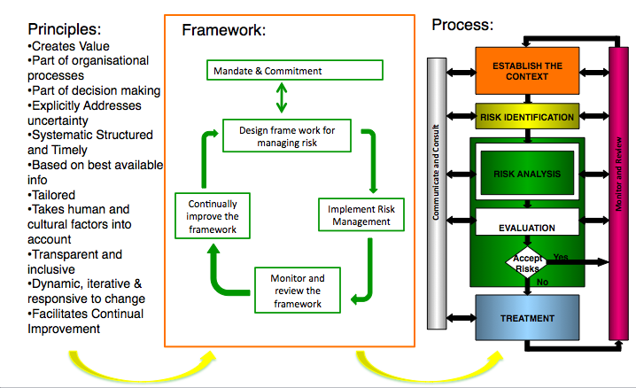
Figure 1: ISO 31000:2009 Risk Management Principles, Framework & Process

Figure 2: Risk Frame Work Adaptation
Organisation
RISK MANAGEMENT
OBJECTIVES
Risk Management Plan
& Program
“Risk Register” & Risk
Treatment Action Plans
Risk Assurance & Performance Reports

The main elements of the Risk Management Process for the Organisation are:

Establish a context

This is a strategic, Organisation and Risk Management context in which the Risk Management Process of the Organisation will take place. Criteria against which Risk will be evaluated should be established and the structure of the analysis defined.

The external context is the external environment in which the Organisation seeks to achieve its objectives. Understanding the external context is important in order to ensure that the objectives and concerns of external stakeholders are considered when developing risk criteria. It is based on the Organisation-wide context, but with specific details of legal and regulatory requirements, stakeholder perceptions and other aspects of risks specific to the scope of the risk management process. The external context can include, but is not limited to:
- the social and cultural, political, legal, regulatory, financial, technological, economic, natural and competitive environment, whether international, national, regional or local;
- key drivers and trends having impact on the objectives of the Organisation; and
- relationships with, perceptions and values of external stakeholders.
- External influencers on the project and its outcomes

The internal context is the internal environment in which the Organisation seeks to achieve its objectives. The risk management process should be aligned with the Organisation's culture, processes, structure and strategy. Internal context is anything within the Organisation that can influence the way in which an Organisation will manage risk. It should be established because:

- risk management takes place in the context of the objectives of the Organisation;
- objectives and criteria of a particular project, process or activity should be considered in the light of objectives of the Organisation as a whole; and
- some companies fail to recognize opportunities to achieve their strategic, project or business objectives, and this affects ongoing Organisation commitment, credibility, trust and value.

- Identify Risks. This is the identification of what, why and how things can arise as the basis for further analysis.

- Analyse Risk. This is the determination of existing controls and the analysis of Risks in terms of consequence and likelihood in the context of those controls. This analysis should consider the range of potential consequences and how likely those consequences are to occur. Consequence and likelihood may be combined to produce an estimated level of Risk.

- Evaluate Risks. This is a comparison of estimated Risk levels (predetermined criteria based on previously experienced qualitative and quantitative measures) against pre-established criteria. This enables Risks to be ranked to identify management priorities. If the level of the Risk established is low, then Risk may fall into an acceptable category and further treatment may not be required.

- Treat Risks. Lower priority Risks may be accepted and monitored. For other Risks, the Organisation is required to develop and implement a specific Risk Management plan including funding considerations.

- Monitor and Review. This is the monitoring, oversight and review of the performance of the Risk Management system and any changes that might affect it. Monitoring and Review occurs concurrently throughout the Risk Management Process.

- Communicate and Consult. Appropriate communication and consultation with internal and external stakeholders should occur at each stage of the Risk Management Process as well as on the process of a whole.

The Risk Management Process is depicted in the following diagram: 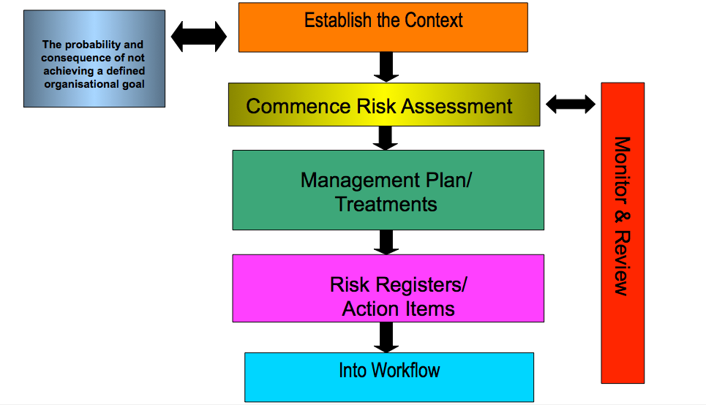
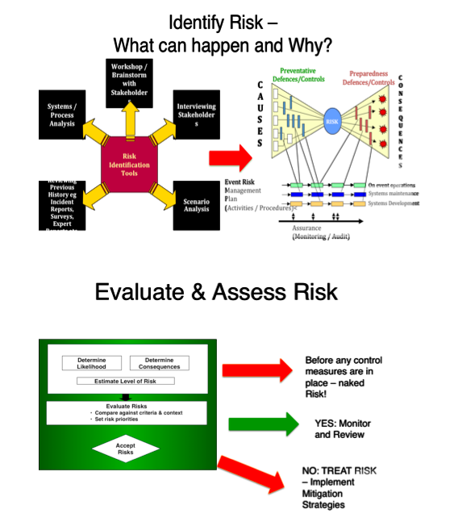

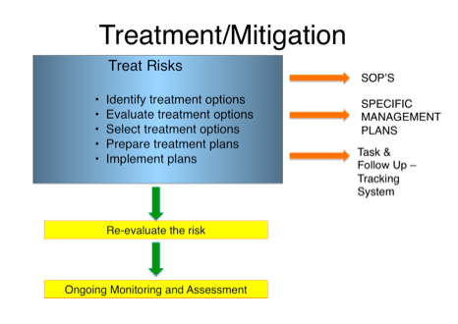

The purpose of this document is to set out a plan for ensuring that Risk Management is considered and included in the overall corporate activities of Southern Tablelands Arts Inc.

The RMP will set out the process of identifying, managing and monitoring risks in relation to all corporate activities and events. Such identification will take into account the relatively small size and scope of the event.

Monitoring risk and review

Southern Tablelands Arts utilises a risk register for all activities that:

- Identifies the significant and material risks impacting the event
- assesses the likelihood of the risk occurring
- assesses the consequences or impact of the risk on the event
- determines an overall grade or rating
- list any mitigation actions or contingency plans required to reduce the risk
- and provides latest mitigation status for each risk.

Risk Criteria

Southern Tablelands Arts uses several key criteria for setting its risk management priorities and thresholds as follows (these being reflected in the corporate Risk Matrix):

- risks affecting the ongoing sustainability of the Organisation
- risks affecting the Organisation’s and partner’s reputation or ability to deliver
- risk affecting public safety and amenity
- risks affecting the overall event management capabilities, including its service delivery obligations, its regulatory framework and business relationships.
- risks affecting the safety, security and health of the event’s participants and the public.
- Cultural and indigenous protocols – where applicable
- Operational risk in relation to strategic and day to day operation of centre
- Environmental
- Political
- Legal and contractual

